|  |
| --- |
|  |
| Water Level Controller of Overhead Tanks Using Water Level Sense  Project Report |
| |  |  |  | | --- | --- | --- | | Irfán Danish, Hammad Munir, Bilal Naeem | 1/1/18 | Electronics-I [EEE231] | |



COMSATS Institute of Information Technology, Islamabad

Department of Electrical Engineering

**Water Level Controller of Overhead Tanks Using Water Level Sense**

Faculty Advisor:

Dr. Armaghan Mohsin

Assistant Professor, CIIT Islamabad

By

Irfan Danish [CIIT/FA15-BEL-012/ISB]

Hammad Munir [CIIT/FA15-BEL-034/ISB]

Bilal Naeem [CIIT/FA15-BEL-007/ISB]

**Submitted in partial fulfillment of the ‘Electronics-I [EEE 231]’ course for Bachelor of Science in Electronics.**

January 01, 2018

© Irfan Danish, Hammad Munir & Bilal Naeem

**Acknowledgments**

*We Would Like To Thank Our Instructor,*

*Dr.* Armaghan Mohsin*,*

*For all his advice & support in the*

*Accomplishment of this project*

*Whose*

*Insight and guidance were invaluable.*

**Chapter Page**

**Acknowledgments……………………………………………………………………………...…….…………..…….….…..………3**

**Summary/Abstract…………………………………..……………………………………………………………….…..…......….…5**

**List of Figures…………………………………..……………………………………………………………….….…………......….… 6**

**Chapter 1: INTRODUCTION…………………………………………………………………………………….……..………..……7**

Background............................................................................................................................................8

Goal……………..........................................................................................................................................8

Scope & Need………………….....................................................................................................................8

**Chapter 2: Component Description................................................................................................9**

Voltage Regulator................................................................................................................................10

Darlington Transistor...........................................................................................................................11

Rectifier Diode ………….........................................................................................................................14

Ultrasonic Sensor ……...........................................................................................................................15

Relay....................................................................................................................................................16

Arduino Uno…………..............................................................................................................................18

**Chapter 3: Working & Efficiency...................................................................................................21**

Block Diagram......................................................................................................................................22

Schematic.............................................................................................................................................22

Simulation Results………….....................................................................................................................23

Cost……………………………….....................................................................................................................26

Extension & Applications.....................................................................................................................27

**Appendix......................................................................................................................................28**

**References...................................................................................................................................29**

**Summary / Abstract**

* This project aims to implement automatic water level controller using an Arduino that would measure the water level and perform switching.
* It was requested on December 11, 2017
* Submitted in partial fulfillment of the course, Electronics-I.
* Project was prepared by:  
   **Irfan Danish [CIIT/FA15-BEL-012/ISB]**

**Hammad Munir [CIIT/FA15-BEL-034/ISB]**

**Bilal Naeem [CIIT/FA15-BEL-007/ISB]**

* Water Level Controller of Overhead Tanks Using Water Level Sense.
* Arduino UNO ATMEGA 328 used to implement the project.
* Arduino IDE used for programming and implementing the code to Arduino UNO.
* Proteus 8.4 Schematic Capture is used for simulation and making schematic of project.
* Microsoft Visio 2016 used to create Block Diagram & Models.
* Major task was to determine the distance of the water in the overhead tank. This information then used to construct a code that would enable the controller to switch the AC motor pump.
* HC-SR04 ultrasonic sensor determines the water level.
* The repositories of project can be accessed by the following link:  
  (<https://github.com/irfandanishdani/Water-Level-Controller-of-Overhead-Tanks-Using-Water-Level-Sense>)

**List of Figures**

There are following number of figures used in this report [Figure Caption; Page Number].

1: LM7805 10

2: Schematic of LM7805 11

3 Protection Diode With 7805 11

4: Darlington Pair Schematic 12

5: Pin Configuration of ULN2003A 14

6: Sonar (Ultrasonic Sensor) 15

7: Timing Diagram of HC-SR04 16

8: Relay Pin Configuration 17

9: Datasheet 17

10: Arduino Uno 18

11: Pin Configuration of Arduino Uno 19

**12**: Block Diagram 22

**13**: Project Schematic 23

14: Overhead tank model 23

**15**: Zone Description 1 24

16: Zone Description 2 24

17: Zone Description 3 25

18: Zone Description 4 25

19: Zone Description 5 26

## **Chapter 1**

**Introduction**

1. **Background:**

Water tank overflow is a common problem in households nowadays. Especially in this part of the world where load shedding is an everyday problem, people undergo water loss or high electricity bills. However, there are many solutions; like ball valves that stop the overflow but the motor is still running. An electrical solution is the best option that can used to stop the tank from overflowing and turning the motor off.

1. **Goal:**

This is an Arduino based water level controller; it controls the motor by sensing the water level in the overhead tank. This prevents the unnecessary functioning of motor. It also prevents the overflowing of water. By installing one of these in a house, we can save water and consume less electricity.

1. **Scope & Need:**

In a third world country like Pakistan, it is very essential for people to have a smart solution to unnecessary electricity bills and wastage of water. In a country where average income is $1,513 a year people need a device that could automatically save their money.

It is one of our sole duty to use our resources sustainably so that the generations to come could be in ease. Wastage of water is becoming common nowadays and one of the biggest reason is the overflowing of water from overhead tanks.

## **Chapter 2**

**Component Description**

We used Voltage regulator LM7805, Arduino Uno, HC-04 ultrasonic sensor, 16x2 dot matrix LCD, motor, buzzer and LED for the development of the project.

1. **Voltage Regulator LM7806:**

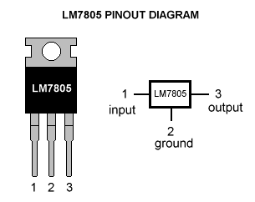Voltage regulator is an electrical or electronic device that maintains the voltage of a power source within acceptable limits. The voltage regulator needed to keep voltages within the prescribed range that can tolerated by the electrical equipment using that voltage.

A voltage regulator perform regulation at both end i.e. it provides source regulation as well as load regulation. In this project, we used LM7805 (3-terminal IC) from 78xx series, which provides fixed 5V at output. It can deliver up to 1.5 A of output current. The internal current-limiting and thermal-shutdown features of this regulator essentially make it safe to overload.

1: LM7805

The input voltage range is from 6-25 volts, whereas the recommended input range is 7-25 volts, maximum recommended current rating is 1.5A at Operating virtual junction temperature of 0-125 oC.

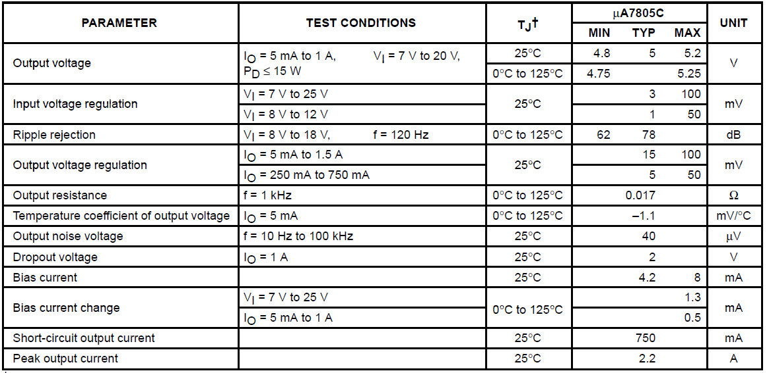Electrical properties of LM7805 as per given by Texas Instruments are given below.

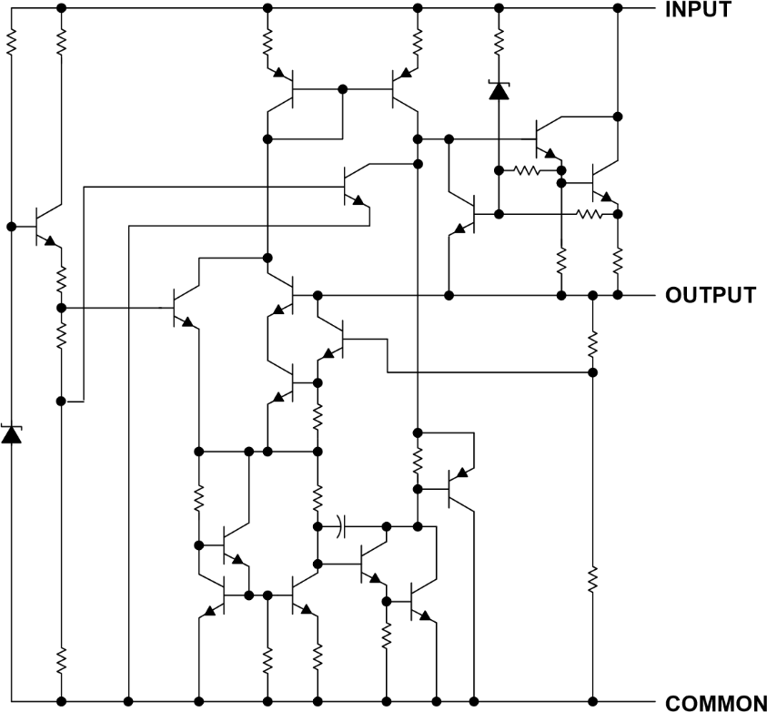

2: Schematic of LM7805

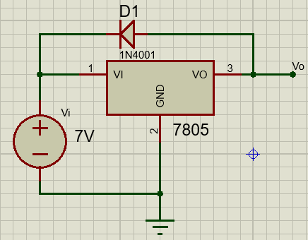An important factor in the use of LM7805 Voltage Regulator is reverse bias protection, occasionally; the input voltage to the regulator can collapse faster than the output voltage. This can occur, for example, when the input supply crowbarred during an output overvoltage condition. If the output voltage is greater than approximately 7V, the emitter-base junction of the series-pass element (internal or external) could break down and be damaged. To prevent this, a diode shunt used between input and output as show in the fig.

3 Protection Diode With 7805

1. **Darlington Transistor:**

Darlington Transistor or Darlington Pair is circuitry in which two transistors are cascaded in such a way that we get the current gain equal to the product of respective current gain of each transistor.

***β = β1 β2***

Where ***β*** is the total current gain we get, ***β1*** current gain of first transistor & ***β2*** current gain of second transistor.

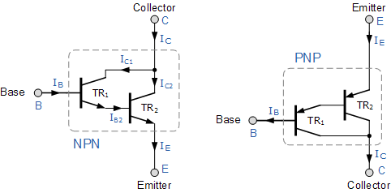

4: Darlington Pair Schematic

Using the NPN Darlington pair as the example, the collectors of two transistors are connected together, and the emitter of TR1 (Transistor 1) drives the base of TR2 (Transistor 2) . This configuration achieves β multiplication because for a base current **I b**, the collector current is ***β* *I b**, where the current gain is greater than one or unity and defined as:

**I = IC1 + IC2**

**IC = β1.IB + β2.IB2  (1)**

But the base current, **IB2** is equal to transistor TR1 emitter current, **IE1** as the emitter of TR1 is connected to the base of TR2. Therefore:

**IB2 = IE1 = IC1 + IB  ∴ IC1 = β1.IB**

**IB2 = β1.IB + IB = IB.( β1 + 1)**

Then substituting in equation 1:

**IC = β1.IB + β2. IB.( β1 + 1)**

**IC = IB.(β1 + β2.β1 + β2 )**

Where β1 and β2 are the gains of the individual transistors. This means that the overall current gain, β given by the gain of the first transistor multiplied by the gain of the second transistor as the current gains of the two transistors multiply. In other words, a pair of bipolar transistors combined to make a single Darlington transistor pair regarded as a single transistor with a very high value of β and consequently a high input resistance.

The advantage of using an arrangement such as this, is that the switching transistor is much more sensitive as only a tiny base current is required to switch a much larger load current as the typical gain of a Darlington configuration can be over 1,000 whereas normally a single transistor stage produces a gain of about 50 to 200.

Then we can see that a Darlington pair with a gain of 1,000:1 could switch an output current of 1 ampere in the collector-emitter circuit with an input base current of just 1mA. This then makes Darlington transistors ideal for interfacing with relays, lamps and motors to low power microcontroller, computer or logic controllers.

In this project, we used ULN2003A, which comes with seven NPN Darlington pairs that feature high-voltage outputs with common-cathode clamp diodes for switching inductive loads. The collector-current rating of a single Darlington pair is 500 mA. The Darlington pairs paralleled for higher current capability. Applications include relay drivers, hammer drivers, lamp drivers, display drivers (LED and gas discharge), line drivers, and logic buffers.

The ULNx2003A devices have a 2.7-kΩ series base resistor for each Darlington pair for operation directly with TTL or 5-V CMOS devices.

Electrical characteristics for ULN2003A are:

|  |  |  |  |  |
| --- | --- | --- | --- | --- |
| **Parameter** | **Test Conditions** | **Min** | **Max** | **Unit** |
| Vcc Collector-Emitter volatge | ---- | - | 50 | V |
| Clamp diode reverse voltage | ---- | - | 50 | V |
| VI Input Voltage | ---- | - | 30 | V |
| Peak collector current | ---- | - | 500 | mA |
| IOK Output Clamp Current | ---- | - | 500 | mA |
| Total Emitter-Terminal current | ---- | - | -2.5 | A |
| Operating free-air temperature range | ---- | -20 | +70 | oC |
| Operating virtual junction temperature | ---- | - | 150 | oC |
| VI(on) ON-state input voltage | VCE=2V, Ic = 200-300mA | 2.4 | 3 | V |
| VOH High-level output voltage after switching | VS = 50 V, IO = 300 mA | -20 |  | mV |
| VCE(sat) Collector-Emitter saturation voltage | II = 250 μA-500 μA,  IC = 100 mA – 350mA | 1.1 | 1.6 | V |
| ICEX Collector cutoff current | VCE=50V, II =0, VI = 6 V | - | 100 | μA |
| VF Clamp forward voltage | IF = 350 mA | - | 2 | V |
| II(off) Off-state input current | VCE = 50 V, IC = 500 μA | 50 | 65 | μA |
| II Input current | VI = 3.85V – 12V | - | 1.35 | mA |
| IR Clamp reverse current | VR = 50 V | - | 50 | μA |
| Ci Input capacitance | VI = 0, f = 1 MHz | 15 | 25 | pF |

The pin diagram for ULN2003A given below:

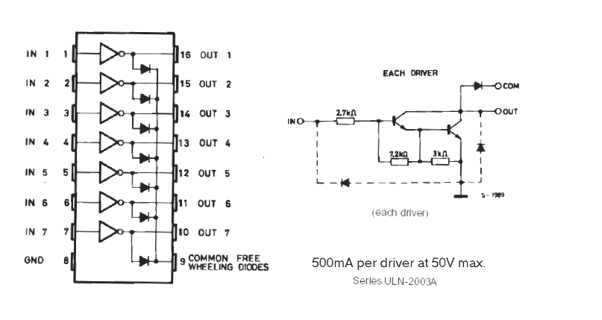

5: Pin Configuration of ULN2003A

Channel 1 through 7 [Pin 1-7] Darlington base input. Channel 1 through 7 [Pin 10-16] Darlington collector output. Common cathode node for fly back diodes (required for inductive loads). Common emitter shared by all channels (typically tied to ground).

1. **Rectifier Diode 10A10:**

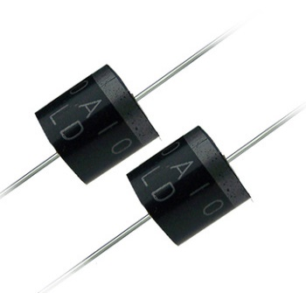A diode is a device that allows the current to flow in only one direction; a diode can be used for rectification, and to prevent flow of current in a particular direction. In this project, we have to prevent the flow of current towards microcontroller if AC Motor pump produces back EMF (Electromotive Force), so we used 10A10 Silicon Rectifier diode. This diode offers very special features; like very low forward voltage drop, high current, capability, high reliability & high surge (instantaneous input current) current capability.

Electrical characteristics of 10A10 silicon rectifier diode are below given.

|  |  |  |
| --- | --- | --- |
| **Type Number** | **Value** | **Units** |
| Maximum Recurrent Peak Reverse Voltage | 1000 | V |
| Maximum RMS Voltage | 700 | V |
| Maximum DC Blocking Voltage | 1000 | V |
| Maximum Average Forward Rectified Current  .375"(9.5mm) Lead Length at Ta=60 C | 10.0 | A |
| Peak Forward Surge Current, 8.3 ms single half sine-wave  superimposed on rated load (JEDEC method) | 400 | A |
| Maximum Instantaneous Forward Voltage at 10.0A | 1.0 | V |
| Maximum DC Reverse Current Ta=25 C  at Rated DC Blocking Voltage Ta=100 C | 10.0  400 | μA  μA |
| Typical Junction Capacitance (Note 1) | 100 | pF |
| Typical Thermal Resistance RθJA (Note 2) | 10 | oC/W |
| Operating and Storage Temperature Range TJ, TSTG | -65 to +150 | oC |

1. **Ultrasonic Sensor:**

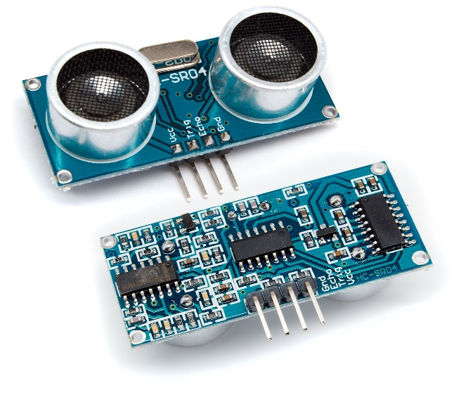The Ultrasonic sound waves has an extremely high pitch that humans cannot hear and is also free from external noises from passive or active sources.

This ultrasonic distance sensor provides steady and accurate distance measurements within the range of 2cm to 450cm. It has a focus of less than 15 degrees and an accuracy of about 3mm.

This particular sensor transmits an ultrasonic sound that has a frequency of about 40 kHz. The sensor has two main parts- transducer that creates an ultrasonic sound wave while the other part listens to its echo and third is control circuit.

The basic principle of work:

* Using IO trigger for at least 10us high level signal,

6: Sonar (Ultrasonic Sensor)

* The Module automatically sends eight 40 kHz and detect whether there is a pulse signal back.
* IF the signal back, through high level , time of high output IO duration is the time from sending ultrasonic to returning.
* Test distance = (high-level time × velocity of sound (340M/S) / 2.

***Electrical Parameters:***

|  |  |
| --- | --- |
| **Working Voltage** | **DC 5 V** |
| **Working Current** | **15mA** |
| **Working Frequency** | **40Hz** |
| **Max Range** | **4m** |
| **Min Range** | **2cm** |
| **Measuring Angle** | **15 degree** |
| **Trigger Input Signal** | **10uS TTL pulse** |
| **Echo Output Signal** | **Input TTL lever signal and the range in proportion** |

*Timing Diagram:*

The Timing diagram shown below. We only need to supply a short 10uS pulse to the trigger input to start the ranging, and then the module will send out an 8-cycle burst of ultrasound at 40 kHz frequency and raise its echo.

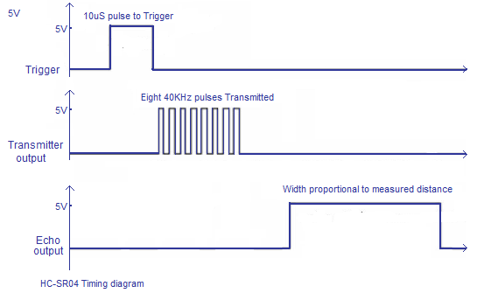

7: Timing Diagram of HC-SR04

The Echo is a distance object that is pulse width and the range in proportion .You can calculate the range through the time interval between sending trigger signal and receiving echo signal.

Formula:

***uS / 58 = centimeters***

***uS / 148 =inch,*** *or the*

***Range (meter) = high level time * velocity (340M/S) / 2***

we have to use over 60ms measurement cycle, in order to prevent trigger signal to the echo signal.

1. **Relay:**

Relays are the primary protection as well as switching devices in most of the control processes or equipment’s. All the relays respond to one or more electrical quantities like voltage or current such that they open or close the contacts or circuits. A relay is a switching device as it works to isolate or change the state of an electric circuit from one state to another. Classification or the types of relays depend on the function for which they are used. Some of the categories include protective, reclosing, regulating, auxiliary and monitoring relays.

In this project, we used “**JQC-3F (T73)”** 6V Single Pole Double Throw relay to switch the motor on and off, this relay has five pins; functionality of each pin defined below.

NC: Normally Closed.

NO: Normally Open (AC Output for the motor.)

COMMON: One of the AC Input applied to it.

Coil VDD: Control Voltage to energize the coil.

Coil GND: Ground.

8: Relay Pin Configuration

Electrical Properties of JQC-3F (T73) relay.

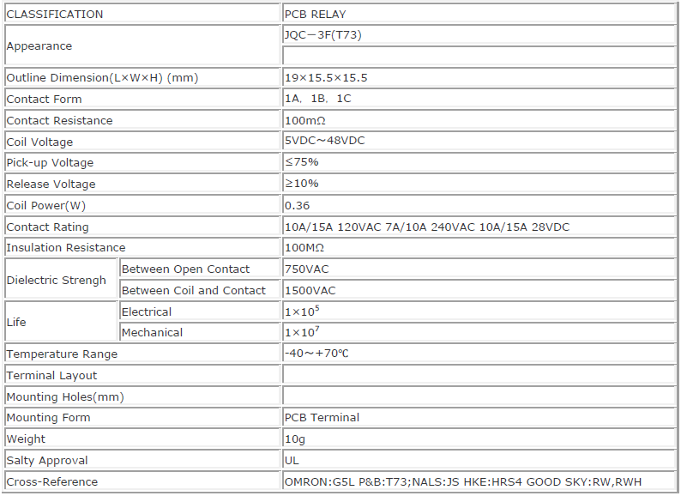

9: Datasheet

1. **Arduino:**

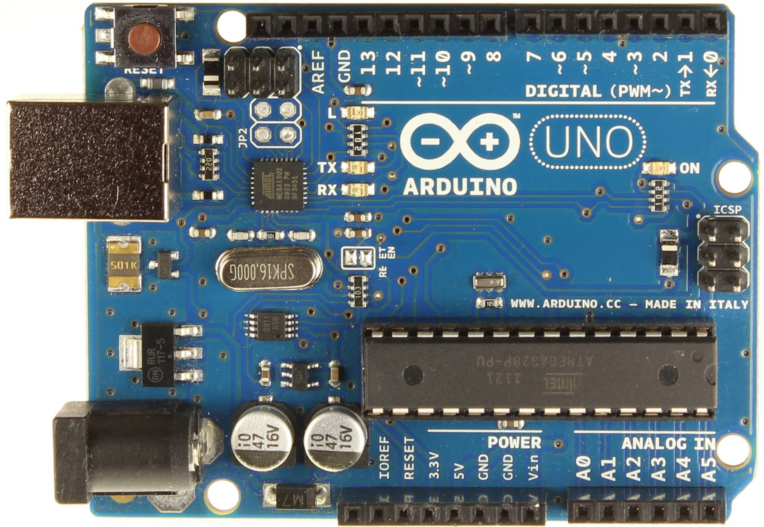The Arduino Uno is a microcontroller board based on the AVR ATmega328. It has 14 digital input/output pins (of which 6 can be used as PWM outputs), 6 analog inputs, a 16 MHz crystal oscillator,10 bit ADC (Analog to Digital Converter) a USB connection, a power jack, an ICSP header, and a reset button.

10: Arduino Uno

Arduino Uno Microcontroller (AT mega 328) operating voltage 5V, input voltage 7-12V recommended. There are total 14 digital I/O Pins (of which 6 provide PWM output) 6 analog input pins. DC Current per I/O Pin is 40 mA DC Current for 3.3V Pin is 50 mA. Flash Memory 32 KB of which 0.5 KB used by bootloader SRAM is 2 KB, EEPROM 1 KB, Clock Speed of 16 MHz

The board can operate on an external supply of 6 to 20 volts. If supplied with less than 7V, however, the 5V pin may supply less than five volts and the board may be unstable. If using more than 12V, the voltage regulator may overheat and damage the board. The recommended range is 5 to 12 volts.

*Power:*

* + VIN: The input voltage to the Arduino board when it is using an external power source (as opposed to 5 volts from the USB connection or other regulated power source). You can supply voltage through this pin, or, if supplying voltage via the power jack, access it through this pin.
  + 5V: The regulated power supply used to power the microcontroller and other components on the board. This either can come from VIN via an on-board regulator, or supplied by USB or another regulated 5V supply.
  + 3V3: A 3.3-volt supply generated by the on-board regulator. Maximum current draw is 50 mA.
  + GND: Ground pins.

*Input & Output:*

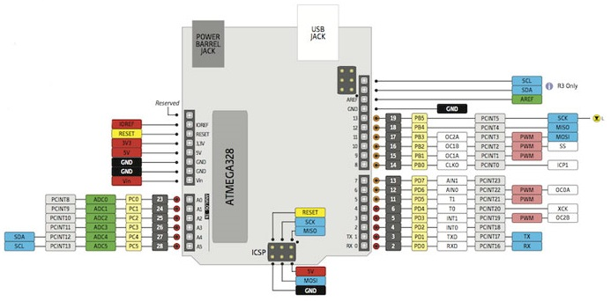Each of the 14 digital pins on the Uno can be used as an input or output, using pinMode(), digitalWrite(), and digitalRead() functions. They operate at 5 volts. Each pin can provide or receive a maximum of 40 mA and has an internal pull-up resistor (disconnected by default) of 20-50 K Ohms. In addition, some pins have specialized functions:

11: Pin Configuration of Arduino Uno

* Serial: 0 (RX) and 1 (TX). Used to receive (RX) and transmit (TX) TTL serial data.
* External Interrupts: 2 and 3. These pins can configured to trigger an interrupt on a low value, a rising or falling edge, or a change in value.
* PWM: 3, 5, 6, 9, 10, and 11. Provide 8-bit PWM output with the analogWrite() function.
* SPI: 10 (SS), 11 (MOSI), 12 (MISO), 13 (SCK). These pins support SPI communication using the SPI library.
* LED: 13. There is a built-in LED connected to digital pin 13. When the pin is HIGH value, the LED is on, when the pin is LOW, it's off.

The Uno has 6 analog inputs, labeled A0 through A5, each of which provide 10 bits of resolution (i.e. 1024 different values). By default they measure from ground to 5 volts, though is it possible to change the upper end of their range using the AREF pin and the analogReference() function. Additionally, some pins have specialized functionality:

* TWI: A4 or SDA pin and A5 or SCL pin. Support TWI communication using the Wire library.
* AREF: Reference voltage for the analog inputs. Used with analogReference()

## **Chapter 3**

**Working**

**& Efficiency**

1. **Block Diagram:**

There are total 12 outputs in the project and only one input given by sonar’s echo pin. Three outputs for LED indicators, one for buzzer, six for 16x2 LCD, one for Sonar’s Trigger pin & one output pin for the control of motor.

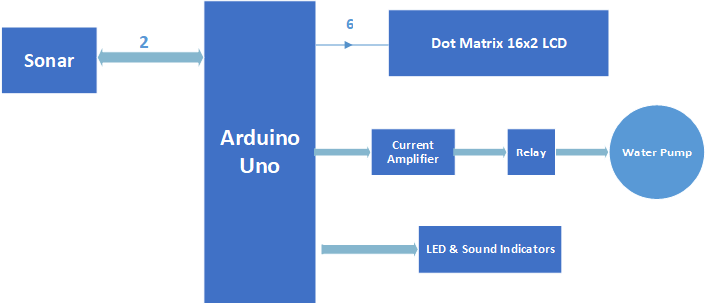

**12**: Block Diagram

1. **Schematic**

The connection of the Arduino given below.

Arduino Pin 0: Connected to RS (Register Select of 16x2 LCD).

Arduino Pin 1: Connected to En (Enable of 16x2 LCD).

Arduino Pin 2: Connected to D4 (Data Pin 4 of 16x2 LCD).

Arduino Pin 3: Connected to D5 (Data Pin 5 of 16x2 LCD).

Arduino Pin 4: Connected to D6 (Data Pin 6 of 16x2 LCD).

Arduino Pin 5: Connected to D7 (Data Pin 7 of 16x2 LCD).

Arduino Pin 6: Connected to trigger pin of Sonar.

Arduino Pin 7: Connected to Echo pin of Sonar.

Arduino Pin 8: Connected to Red LED.

Arduino Pin 9: Connected to Yellow LED.

Arduino Pin 10: Connected to Green LED.

Arduino Pin 11: Connected to Buzzer.

Arduino Pin 12: Connected to ULN2003A.

Arduino Pin Vin: Connected to output of voltage regulator

Arduino Pin GND: Connected to the ground.

As soon the system will turn on, Sonar will measure the distance of water & send the results to Arduino Uno, Arduino will calculate the percentage of water if it will greater than defined lower value it will only display the water level. If water percentage will less than the Defined Lower Value, it will send a high signal to ULN2003A and as a result ULN2003A will energize the coil of relay and motor will be turned on.

Schematic of the system shown below.

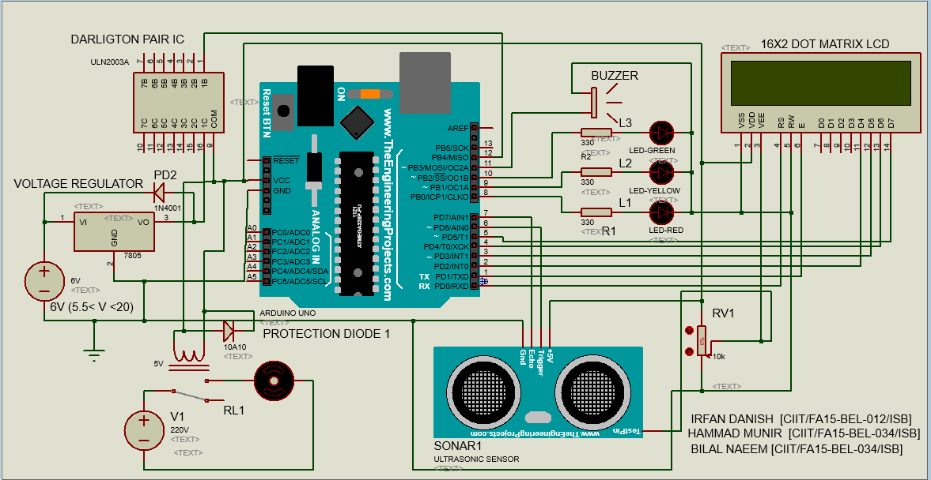

**13**: Project Schematic

1. **Working & Simulation Results:**

We have defined two zones for water pump,

* Water level greater than 90%.
* Water level less than 10%.

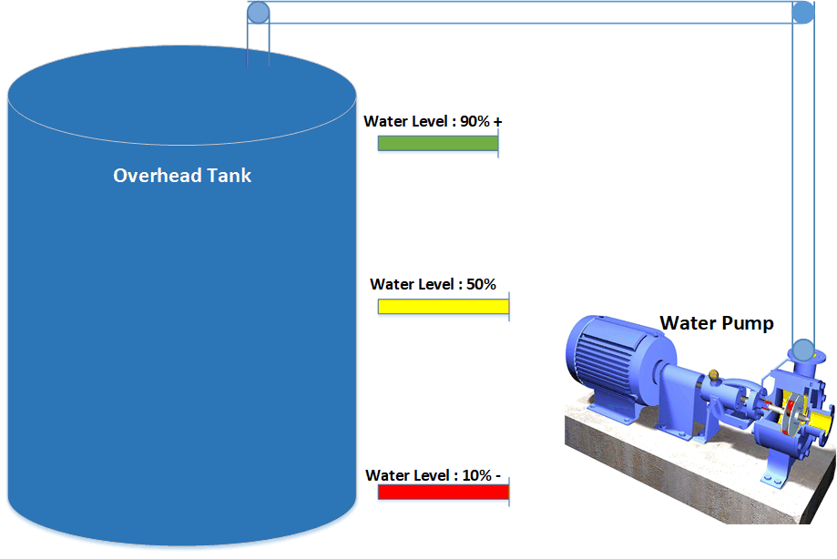 Consider the following model of water pump and overhead tank.

14: Overhead tank model

Initially we consider that the water level in overhead tank is full i.e. 100% so our must be switched off in that case and we can see that from relay, which is at normally closed state.

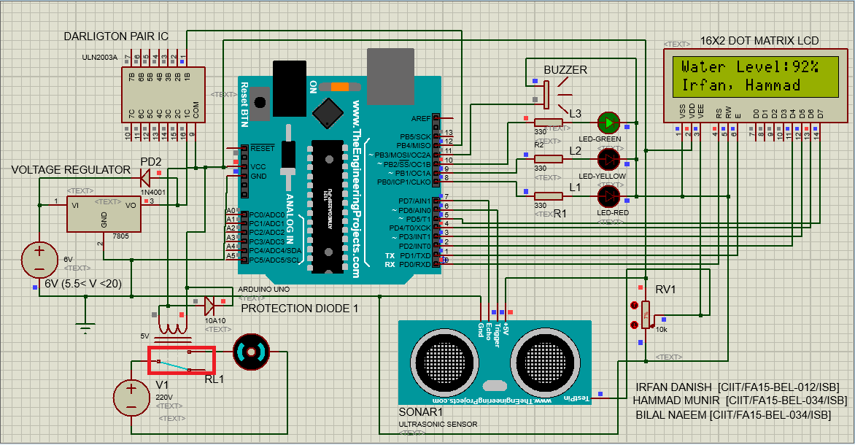

**15**: Zone Description 1

In second stage when someone starts consuming water, the water level starts falling, a high to low transition of water level will occur and water pump (motor) should remain off because water level has not reached the prescribed level i.e. 10%.

The result for -10% ≤ Water Level ≤ -90 % shown in the figure. The negative sign indicates that the water level is decreasing.

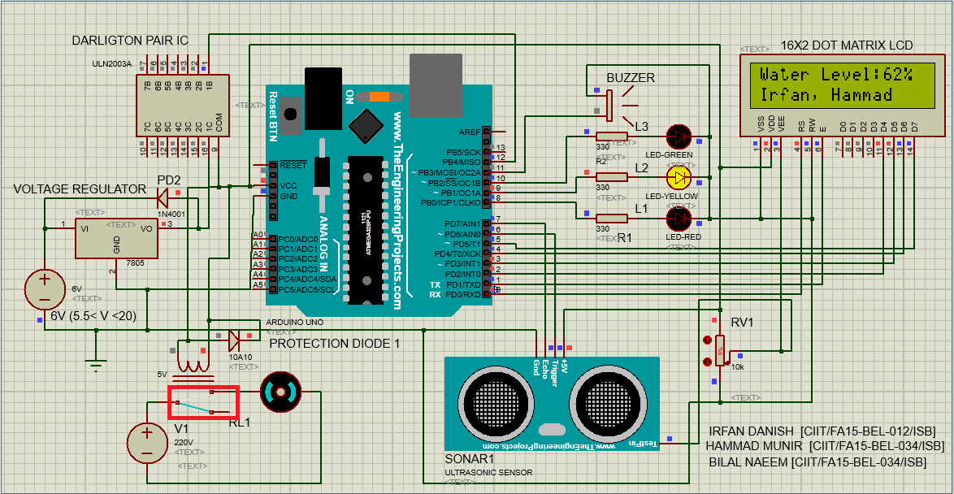

16: Zone Description 2

As the water level starts decreasing after it drops to 10% level motor will turn on as the controller provide the high signal (5V) to ULN2003A which on receiving the High Signal will turn on the relay as a result water pump (motor) will start working.

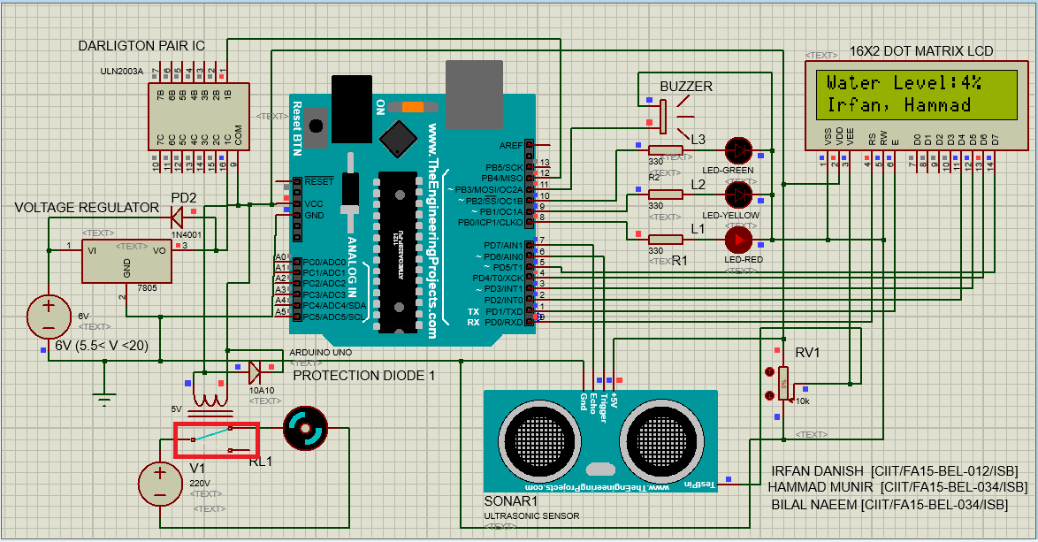

17: Zone Description 3

Water pump (motor), should remain on until the water level reaches to 90/100%, we named this process low to high transition of water level.

The result for +10% ≤ Water Level ≤ +90 % shown in the figure. The positive sign indicates that the water level is increasing.

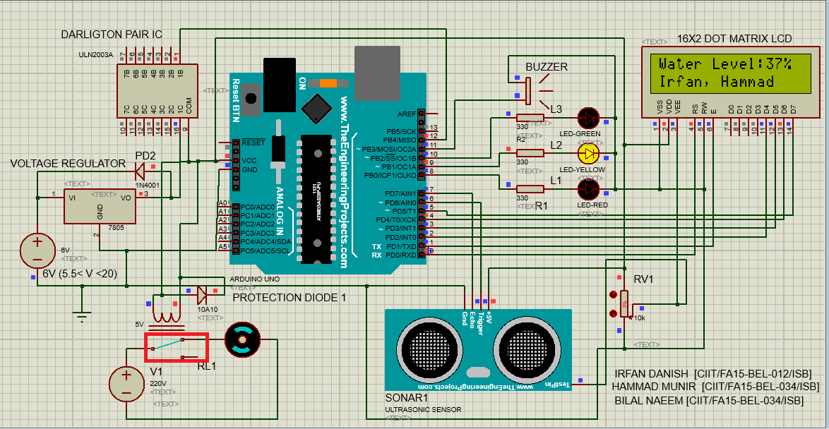

18: Zone Description 4

As the water pump (motor) is working as the water level reaches the 90 / 100%, the controller will give a low signal (0V) to ULN2003, which as a result will turn off the relay, and water pump (motor) will stop working. Shown in the figure.



19: Zone Description 5

1. **Cost:**

The total cost on this project is 1240 PKR or approximately $12 only.

**Component** **Price**

Sonar: 200

Arduino Nano: 350

16x2 Display: 200

Relay (20A): 200

Darlington Transistor: 40

LM7805: 30

LED & Buzzer: 20

PCB: 100

Box: 100

_____________________________

**Total 1240**

By Eliminating 16x2 Display, we will have this controller in 1040 PKR ($10) & if there is need to reduce the cost further then we can use a non-ready microcontroller instead microcontroller board, which will reduce the cost approximately to 900 PKR ($9) only.

1. **Extensions & Applications:**
2. By adding Wi-Fi (Controller Node MCU or Wi-Fi Module), we can control our water pump even if we are somewhere else in the world.
3. We can create blind stick using Ultrasonic Sensor & Arduino.
4. It can also use for counting persons in a particular space.
5. Vehicle detection for car wash and automotive assembly.
6. Irregular parts detection for hoppers and feeder bowls.
7. Contouring or profiling using ultrasonic systems.
8. 45° Deflection; inkwell level detection.
9. Loop control.
10. Roll diameter, tension control, winding and unwind.
11. Thru beam detection for high-speed counting.
12. Thread or wire break detection.

**Appendix:**

LCD: Liquid Crystal Display.

LED: Light Emitting Diode.

β : Current gain of Bipolar Junction Transistor

AC: Alternating Current.

DC: Direct Current.

EMF: Electromotive Force

RMS: Root Mean Square Value.

SPDT: Single Push Double Throw.

NC: Normally Closed.

NO: Normally Open

PWM: Pulse Width Modulation

ADC: Analog to Digital Converter.

ICSP

USB: Universal Serial Bus.

SRAM: Static Random Access Memory.

EEPROM: Electronically Erasable Programmable Random Access Memory.

KB: Kilo Byte.

I/O: Input /Output.

RX: Receiver.

TX: Transmitter.

TTL: Transistor-Transistor Logic.

SPI: Serial Peripheral Interface.

MOSI: Master In Slave Out.

SCK: Serial Clock.

SS: Slave Select.

AREF: Analog Reference Voltage.

SDA: Data Line.

SCL: Clock Line.

Wi-Fi: Wireless Fidelity.

MCU: Microcontroller

PCB: Printed Circuit Board.

PKR: Pakistani Rupees.

$: American Dollar.

**References:**

* + *Datasheet of: 10A005 THRU 10A10 High Power Rectifier Diode Series.*
  + *Datasheet of: μA7800 SERIES POSITIVE-VOLTAGE REGULATORS from Texas Instruments.*
  + *Datasheet of: ULN200x, ULQ200x High-Voltage, High-Current Darlington Transistor Arrays from Texas Instruments.*
  + *Datasheet of: JQC-3F (T73) SPDT Relay SERIES.*
  + [*http://inpressco.com/category/ijcet*](http://inpressco.com/category/ijcet)*.*
  + [*https://www.geeetech.com/wiki/index.php/Arduino_Uno*](https://www.geeetech.com/wiki/index.php/Arduino_Uno)
  + [*https://www.robomart.com/blog/working-of-hc-sr04-ultrasonic-sensor-with-arduino-uno/*](https://www.robomart.com/blog/working-of-hc-sr04-ultrasonic-sensor-with-arduino-uno/)
  + [*www.Elecfreaks.com;HC-SR04*](http://www.Elecfreaks.com;HC-SR04)
  + [*https://www.migatron.com/ultrasonic-detections-and-control-applications/*](https://www.migatron.com/ultrasonic-detections-and-control-applications/)
  + [*https://www.elprocus.com/different-types-of-relays-used-in-protection-system-and-their-workings/*](https://www.elprocus.com/different-types-of-relays-used-in-protection-system-and-their-workings/)
  + *http://www.alldatasheet.com/datasheet-pdf/pdf/157071/DBLECTRO/JQC-3FC.html*